**Lesson 12 Demo 1**

**Configuring Jfrog Artifactory for publishing Artifacts**

Steps to be followed:

1. Install Jfrog Artifactory on Ubuntu VM
2. Log in to Jenkins CI tool and install Artifactory Plugin

**Step 1: Install Jfrog Artifactory on Ubuntu VM.**

1. Download Jfrog Artifactory open-source version which does not need any license and can be installed free of cost.

**https://jfrog.com/open-source/**

1. You can select the platform on which you want to install artifactory and according to the platform you would be able to deploy artifactory. As per our lab we will be using the **linux installer.**

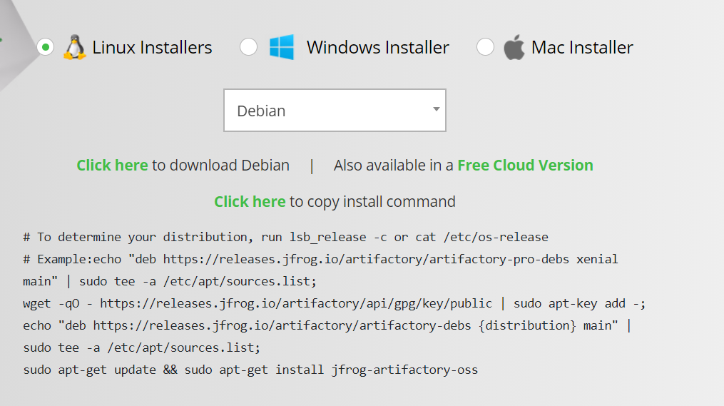

1. Login to Ubuntu VM and connect with root user to install Artifactory. Make sure artifactory service is up and running.

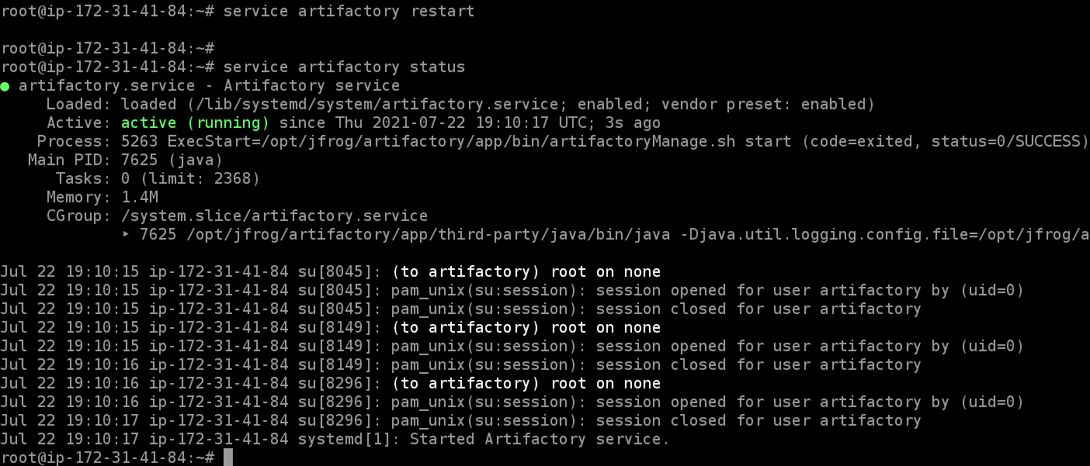

1. Once Artifactory is deployed access artifactory using VM ip and 8082 port.
2. Login with Artifactory using below credentials:

Username: admin Password: password

1. By default, you would be having a basic repository but you also have access to create a custom Artifactory repository.

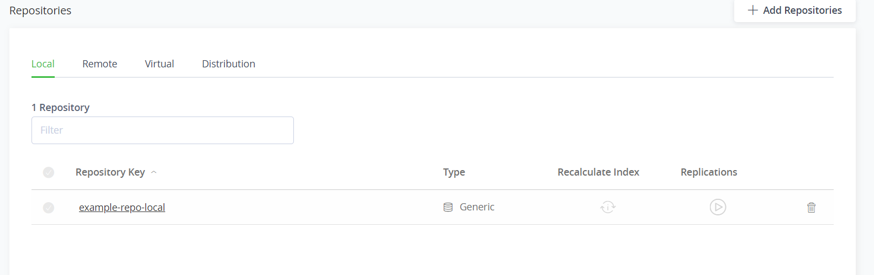

**Step 2: Log in to Jenkins CI tool and install Artifactory Plugin.**

1. Login to Jenkins CI tool with admin user and navigate to Manage Jenkins and Manage Plugins.

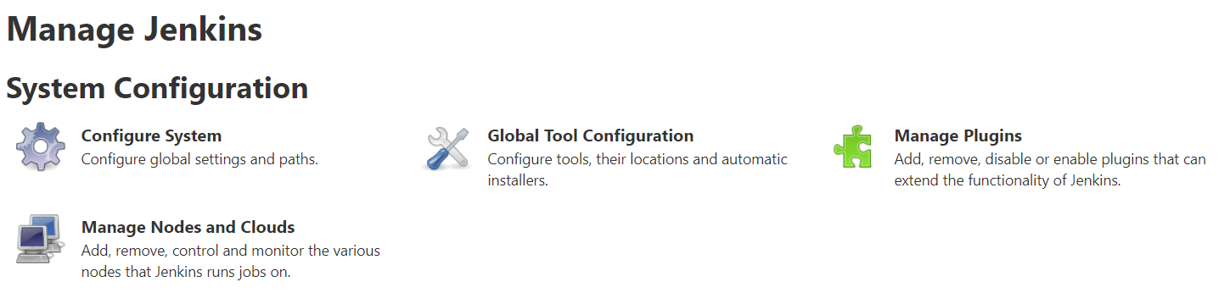

* 1. Then navigate to **Available** tab and search for **Artifactory plugin**.

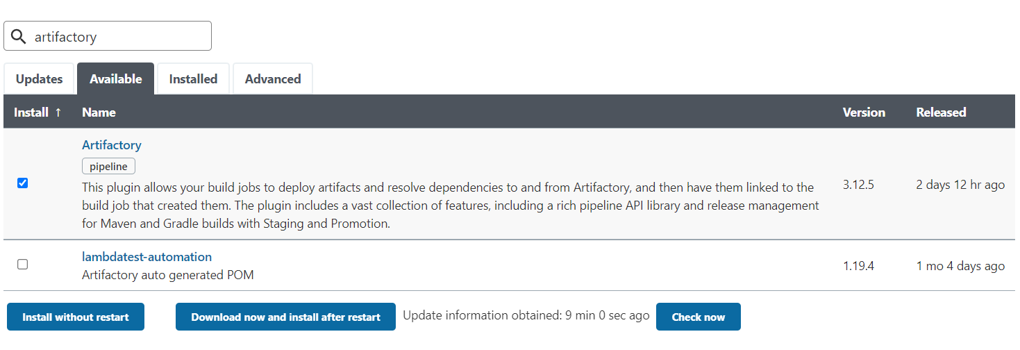

* 1. Now user need to configure artifactory in Jenkins. Login to Manage Jenkins 🡪 Configure System.
  2. Use below screenshot for reference on how to mention connection details from Jenkins to Jfrog artifactory.

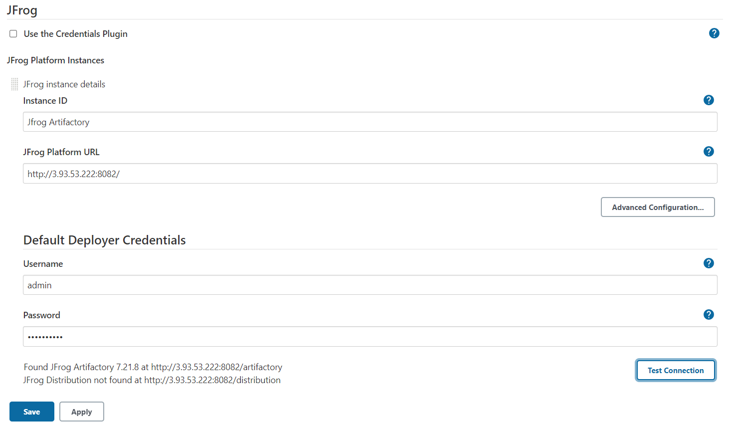

* 1. Once Test connection is successful, save the configuration.